Operation Endgame Solution Documentation
Written By: Yuval Quina
I started this challenge by executing the following Nmap ports and services scan: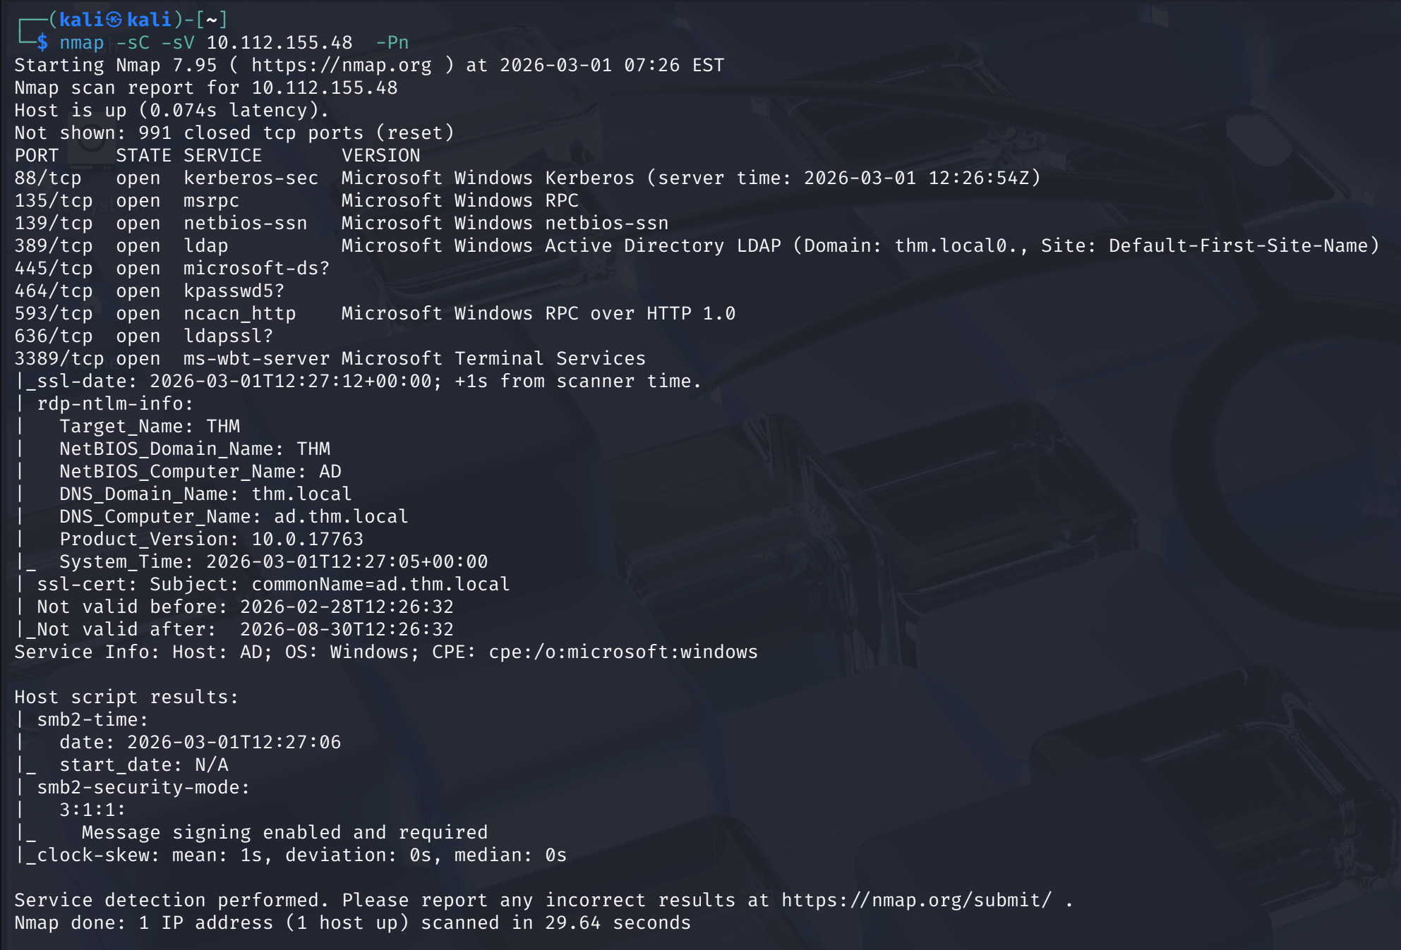
According to the result, the target runs on windows active directory (because of the open ports like 88(Kerberos-sec) and 445 (SMB)). I also accessed the machine using the browser to confirm this assumption:
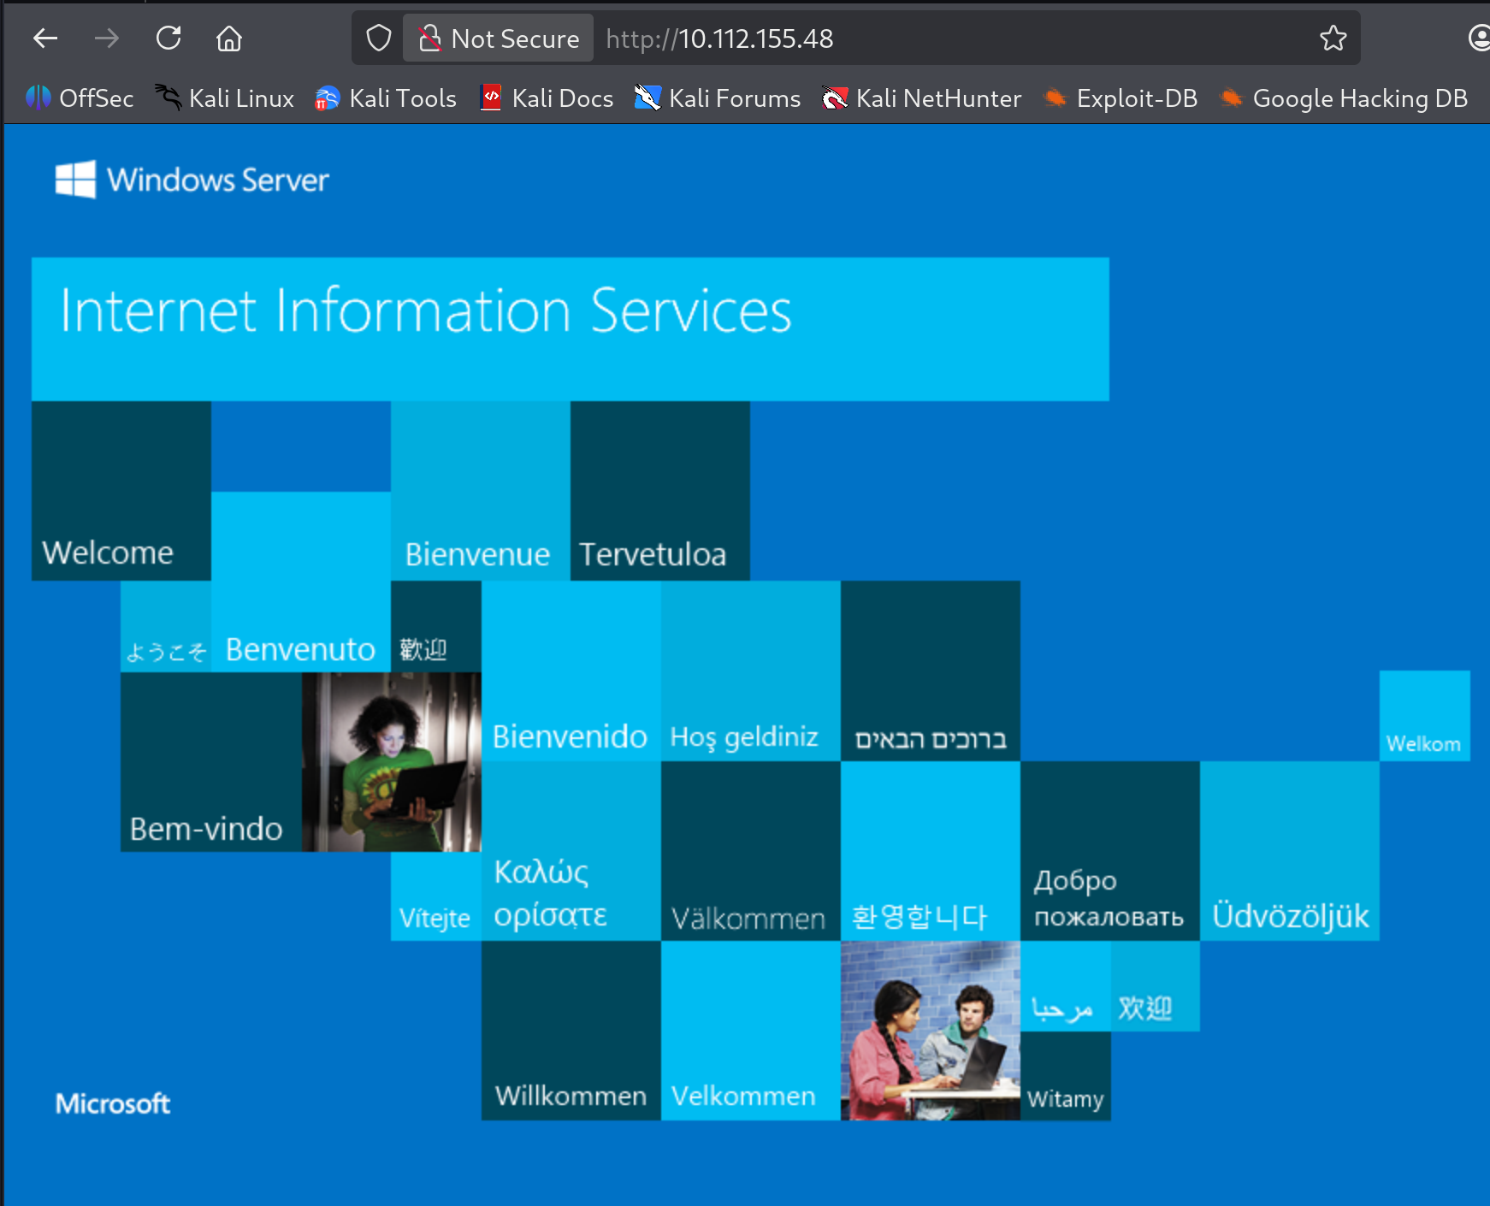
On this point, I needed more info about the target, so I run a scan on its active directory using a tool named “enum4linux”:
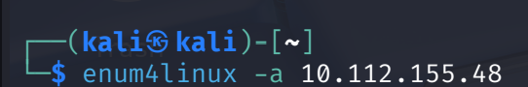
I examined the results to find useful information. I found that the NetBIOS domain is “THM”:
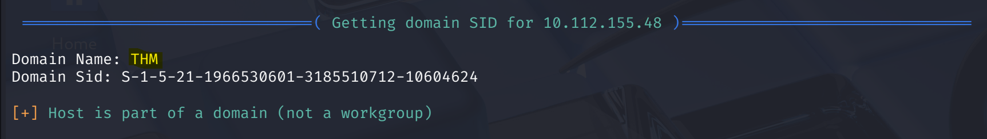
This led me to find also the target’s DNS domain. For this task, I used a tool named “crackmapexec”:
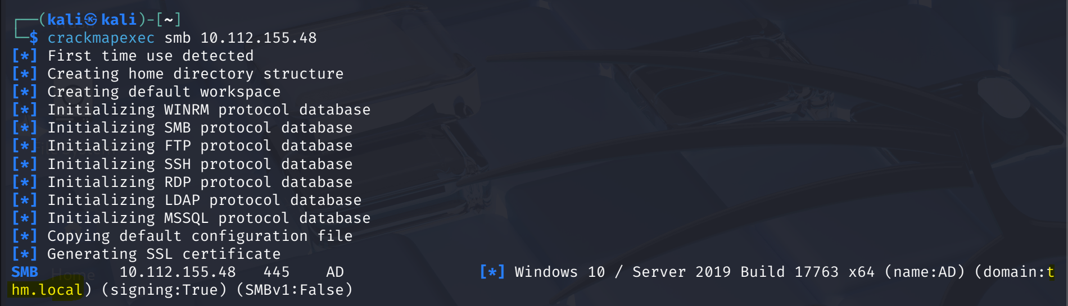
And it’s “thm.local”.
After acquiring the target’s DNS domain, I could execute users Kerberos bruteforce attack using a special utility named “kerbrute” (you can find it here: https://github.com/ropnop/kerbrute):

